Issue Link:-

<https://github.com/AR-js-org/AR.js/issues/338>

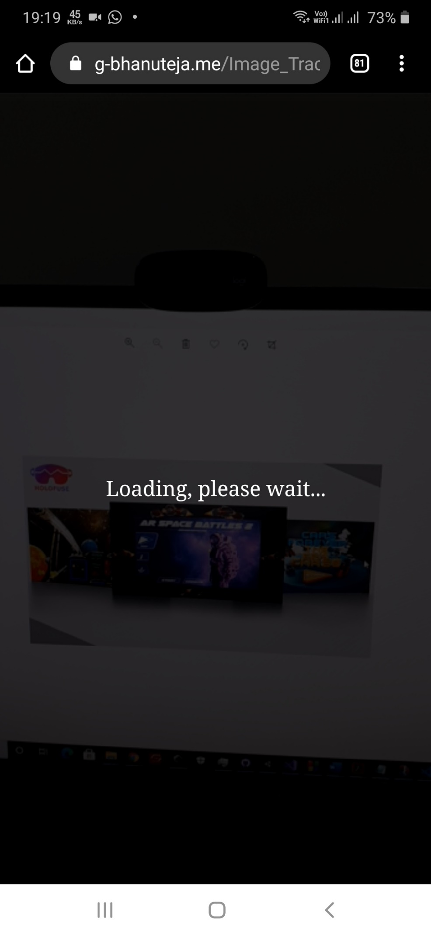

Today I tried Image Tracking based WebAR using A-Frame and AR.js, I have followed the AR.js documentation as shown here:-

<https://ar-js-org.github.io/AR.js-Docs/image-tracking/>

and the samples by AR.js on GitHub to create my project, but it's not working as expected. It just shows this Loading message that is there in the body and in background, it accesses the Camera of the device but it's not tracking the Image Descriptor. Why is it happening like that? I have tried the live(hosted) example by AR.js, in that also the same issue was there

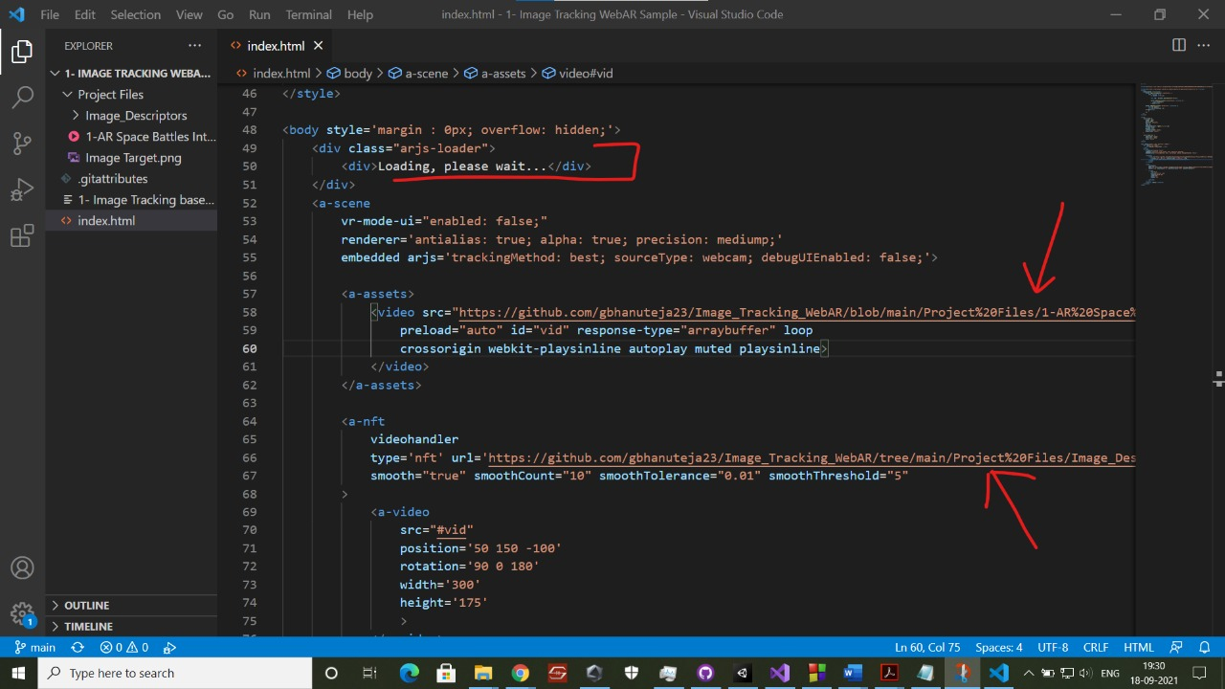

Where as I had once again tried the Demo WebAR project that I had made using ARWT SDK using which WebAR projects can be developed using Unity itself, it's working perfectly ( It also uses A-Frame and AR.js internally but it's working )

